SCFMS Test Case Screenshots
Login
Test Case 1:

Test Case 2:
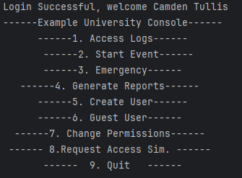
Access Logs
Test Case 3:
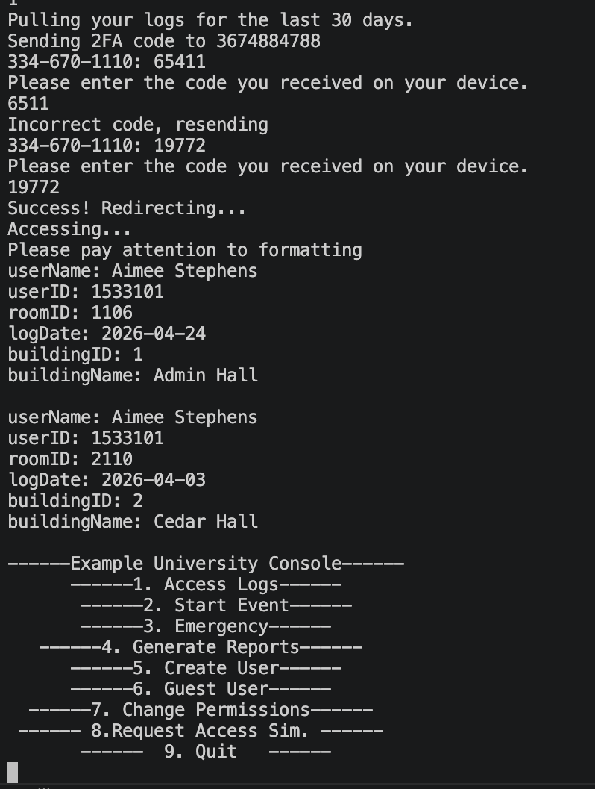
Start Event
Test Case 1:
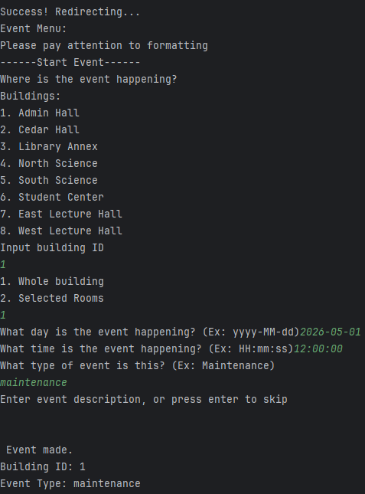
Test Case 2:
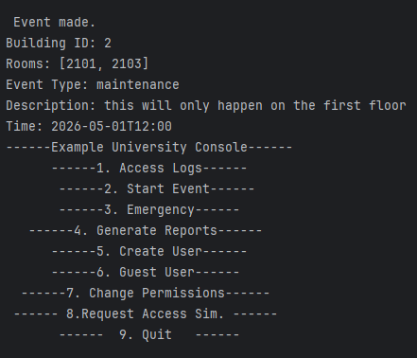
Emergency
Test Case 1:
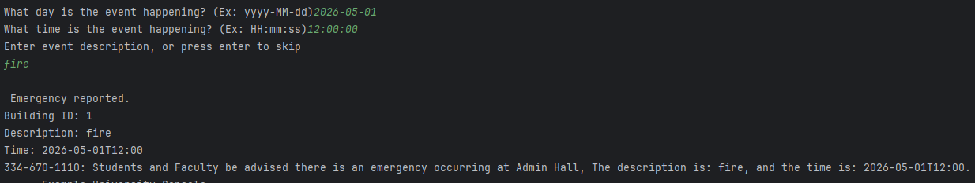
Test Case 2:
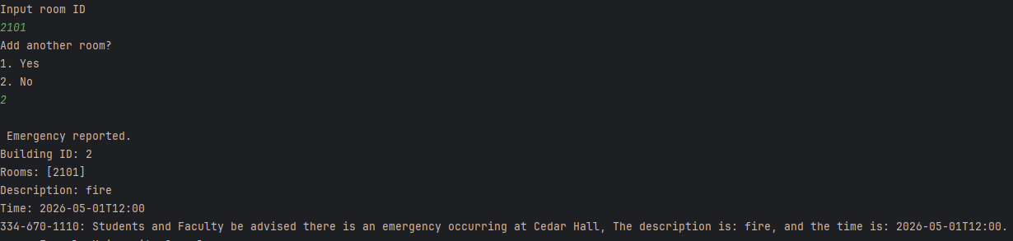
Generate Reports
Test Case 1:
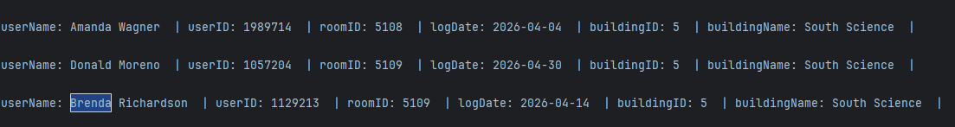
Create User
Test Case 1:
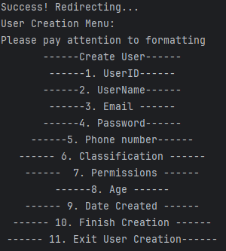
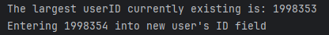
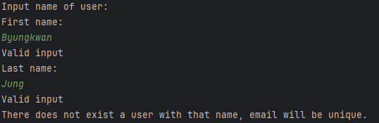
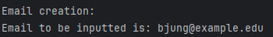
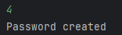
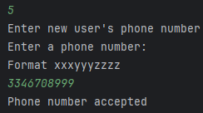
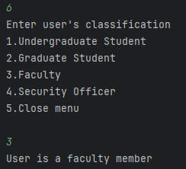
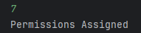
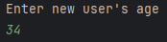
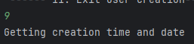
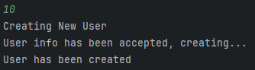
Guest User
Test Case 1:
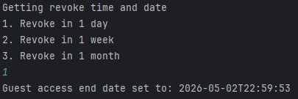

Change Permissions
Test Case 1:
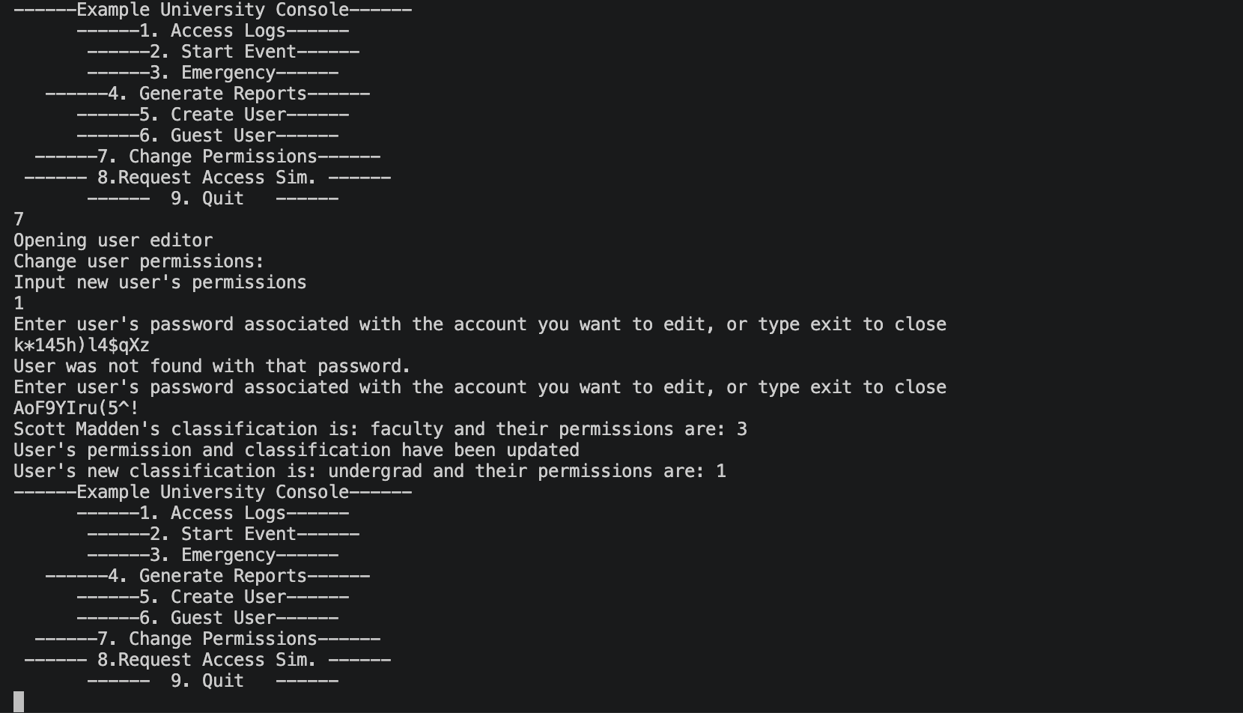
Request Access
Test Case 1:
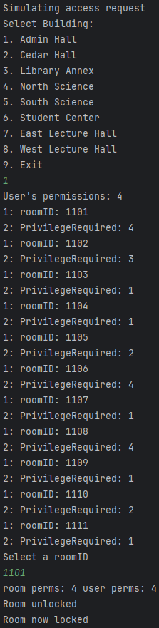
Test Case 2:
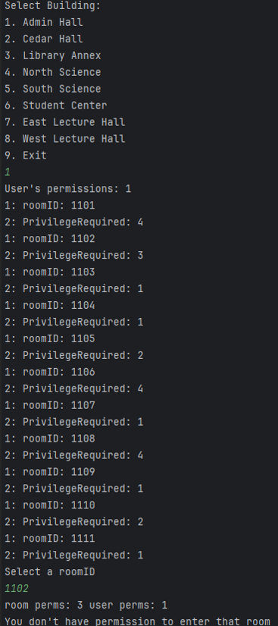
Encryption- Security
Test Case 1:
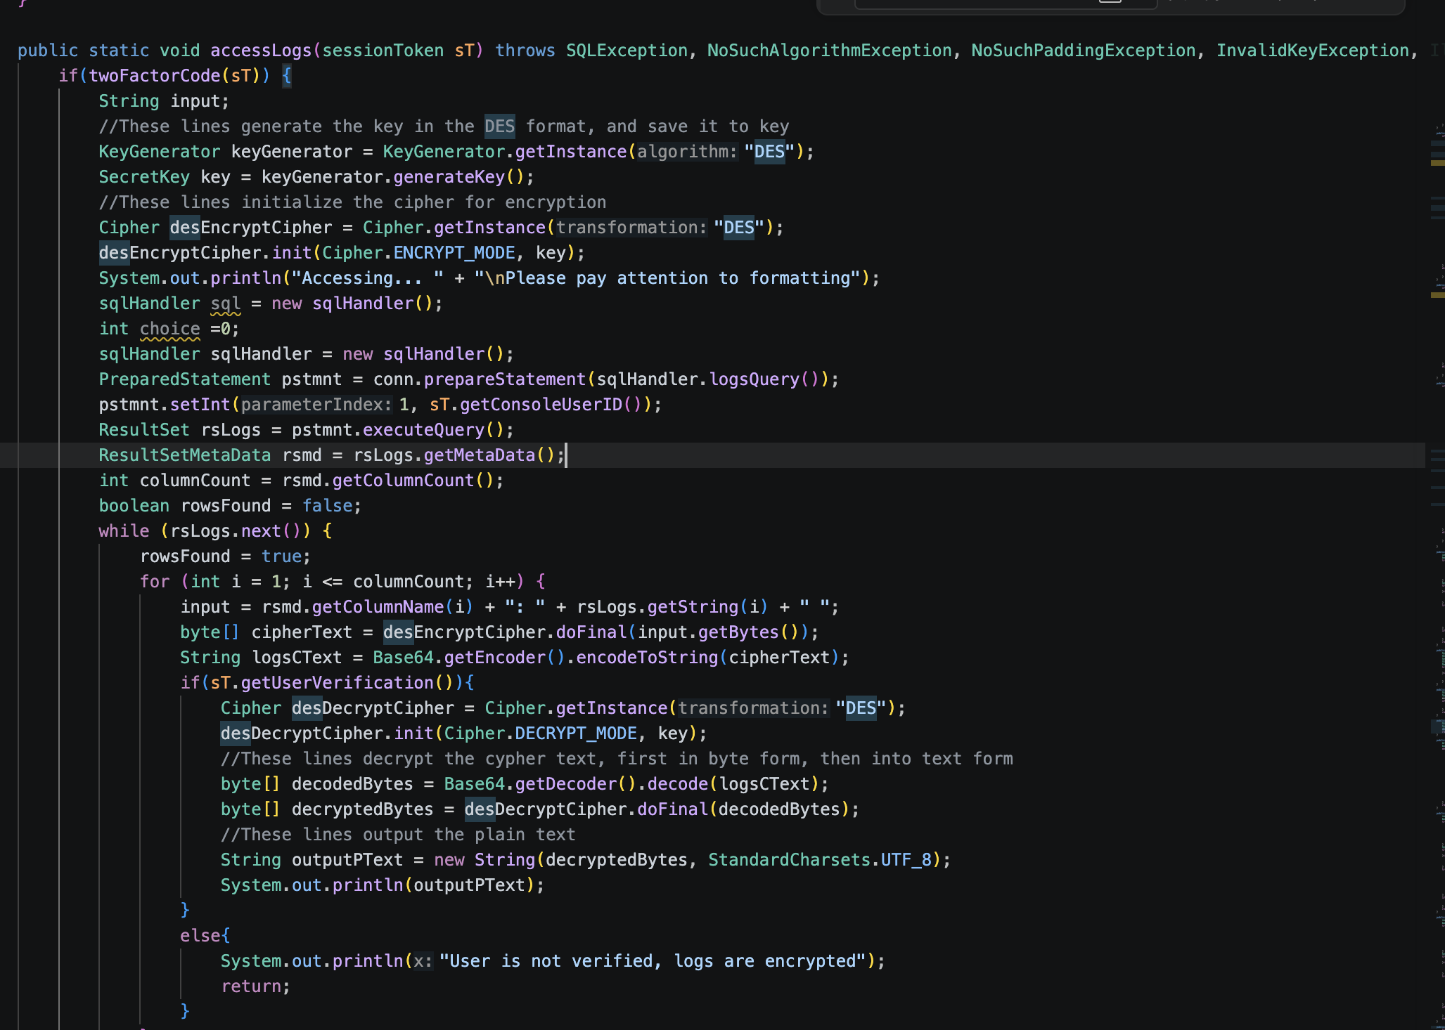
2FA- Security
Test Case 1:
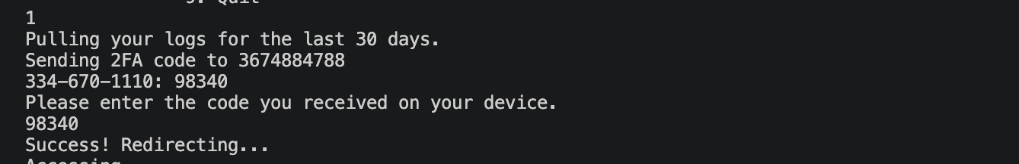Test Case 2:
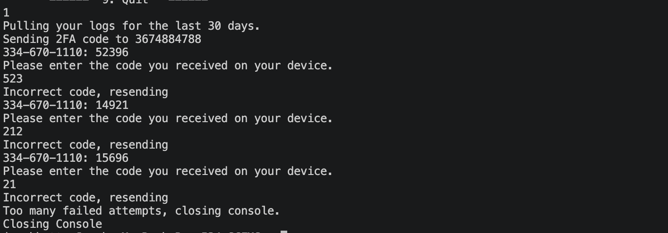
Monitoring- Security
Test case 1:
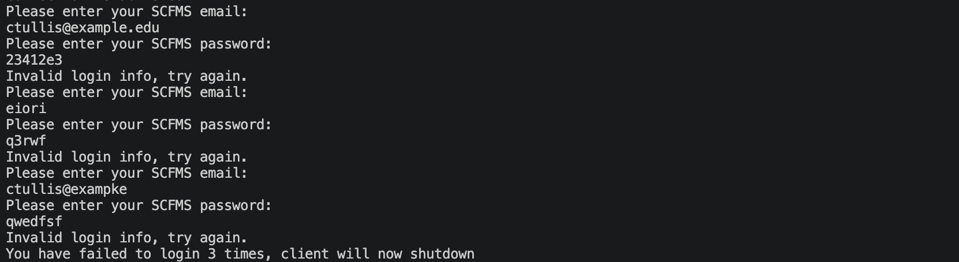
Test case 2:
(on attempt number 2)
